Nature has been in existence long before humans and ever since it has taken care of mankind and nourished it forever. In other words: it offers us a protective layer that guards us against all kinds of damages and harms. Survival of mankind without nature is impossible and humans need to understand that. If nature has the ability to protect us: it is also powerful enough to destroy the entire mankind. more holds equal significance for us. The absence of one element is enough to cause a catastrophe in the functioning of human life. We fulfill our healthy lifestyle by eating and drinking healthy: which nature gives us. Similarly: it provides us with water and food that enables us to do so. Rainfall and sunshine: the two most important elements of survival are derived from nature itself

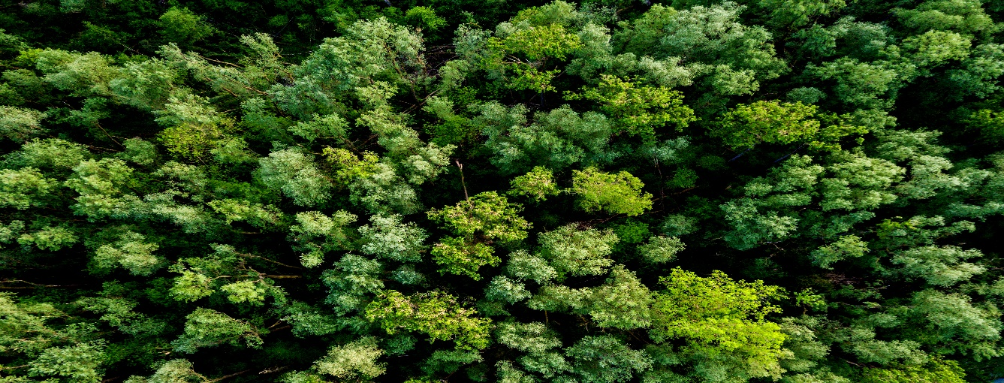

Figure

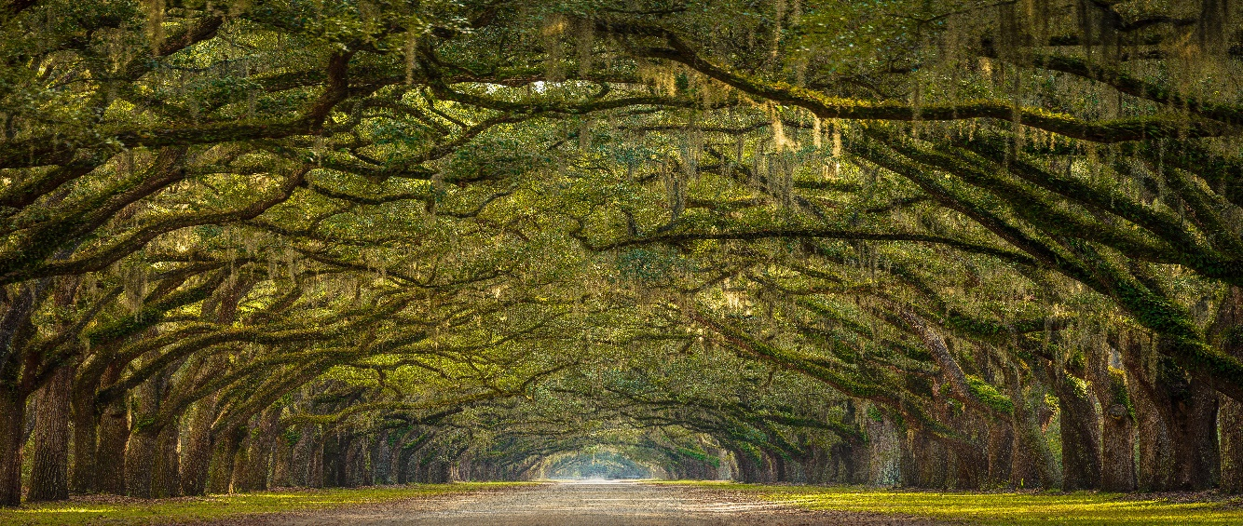

Figure

Figure 1 1

Figure 2 1